To register your iClicker remote online, log into our Blackboard course and find this link:

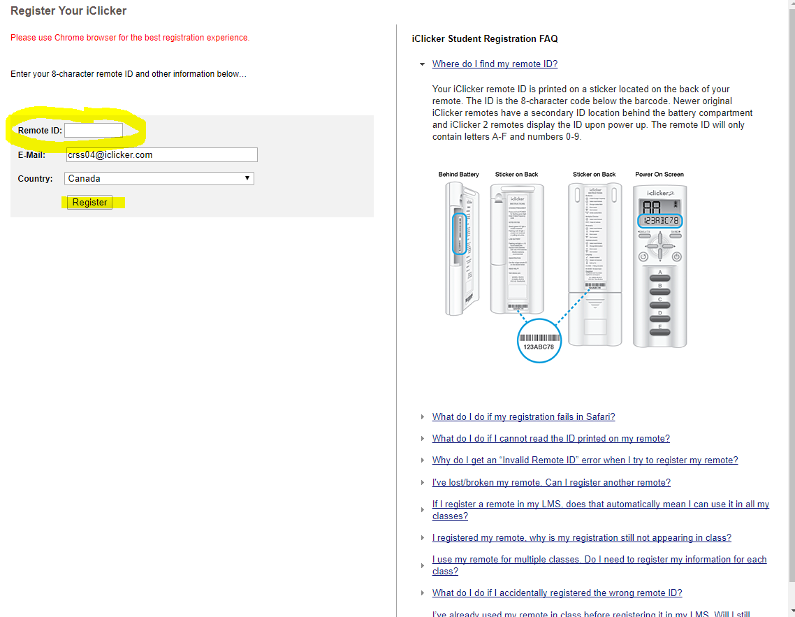

Enter your 8-digit remoteID number; Blackboard will already have your student email address populated, so just click “Register” and you are done.

Or

If you are voting in class with the iClicker Reef mobile app, please Add this course, update student ID in your profile and extend your subscription!

NOTE: Students using iClicker Reef mobile app will appear as "Unknown REEF User"
in the instructor’s iClicker gradebook until 1) they have entered their Blackboard Username as their student ID (as it appears in your roster) in their REEF profile and 2) your instructor has synchronized the roster by clicking the "Sync Roster" button in the gradebook.

If you need help registering, please contact
support@iclicker.com
1-866-209-5698
9am-11pm EST Monday-Thursday
9am-9pm EST Friday

