CSCE 531 – Compiler Construction - Test 1
October 22, 2004

Throughout the test the symbol ε (epsilon) will be used to denote the empty string.
*** problems are due Sunday Midnight, the rest are due dropboxed by 9:00PM tonight.

- Give LEX regular expressions for:
  - Strings of A’s, B’s and C’s such that every two C’s are separated from each other by at least one A and at least one B.

  - Describe in English the language specified by the regular expression
(0 | 01 | 001 | 0001)*1.

- RegExpr ➔ NFA
  - Convert the regular expression (xyz | (b | a)*)* to an NFA using the Thompson construction. You can either draw this and scan it or just give a table of the form:
State | x | y | z | a | b
Si | Transitions from Si on x

  - ***Suppose r and s are regular expressions for which the NFAs M_{r} and respectively M_{s} accept the language represented by the regular expressions, i.e., L(r) = L(M_{r}) and L(s) = L(M_{s}) then show and describe how an NFA could be constructed that will accept the language L(r) ∩ L(r). For simplicity you may assume that the NFAs were constructed with the Thompson construction.

- NFA ➔ DFA.
  - What is the maximum number of states in a DFA constructed from an NFA with n states?

  - What is the fewest number of states in a DFA constructed from an NFA with n states?

  - Given the NFA shown below construct an equivalent DFA, assuming S0 is the initial state and S3 is the final state.

State | ε | a | b
S0 | S1,S2 | S3 | S0
S1 | Φ | Φ | S3
S2 | S1 | S2 | Φ
S3 | Φ | Φ | S3

  - Are there any indistinguishable states in this DFA? If so identify a pair.

  - Are there any distinguishable states in this DFA? If so identify a pair and give what distinguishes them.

- Grammars, ambiguity, derivations and languages: Given the grammar below
N → ( N ) | ( N ) N | ε
  - Give a rightmost derivation of ( ) ( ( ( ) ( ) ) )

  - Draw the corresponding parse tree

  - ***Prove this grammar is ambiguous?

- First and Follow Calculations
  - Calculate First and Nullable for the Grammar
S → B c W a | d
B → B b | a
W → a | E F
E → x | ε
F → y | ε

  - In the Calculation of FOLLOW assume that the value of the First sets and Nullable are given below
Nonterminal X | First(X) | Is X nullable? | Follow(X) at this point
A | { f,a} | No | {a, b, eof}
B | { a, b } | No | Φ
C | {w,r} | Yes | Φ
D | {s,t} | No | Φ
F | {x} | Yes | Φ
Show the changes to the follow sets by examining the production “A → BCBDF.” Just once through the main loop of the algorithm from here not iteratively processing this production over and over.

- For the grammar L → L a N | c
N → b N | ε
  - What is L(G)?

  - Write a recursive parsing routine for N assuming parsing routines for the other nonterminals for the grammar segment given below (this is all of the N productions). N → a N c | b N c | d

  - *** Prove a by induction.

- Assuming the following
Nonterminal X | First(X) | Is X nullable? | Follow(X)
S | { a, b, c} | Yes | {a, eof}
U | {b,c} | No | {r,a,c}
V | {c} | No | {a,b}
W | {a, c, ε} | Yes | {eof}
R | {r} | Yes | {eof}
T | {a, r} | No | {a,c,eof}
Show as much of the LL(1) table as is possible (column and row labels).

  - Now consider the production “U→W V T R” and insert it into the table in the appropriate places.
  - Now consider the production “W → ε” and insert it into the appropriate places
  - How do you tell if a grammar is LL(1)?

- Given the LR(1) sets of items below show the entries (rows) in the LR(1) parse table for states 6 and 12. In this diagram $ means eof.
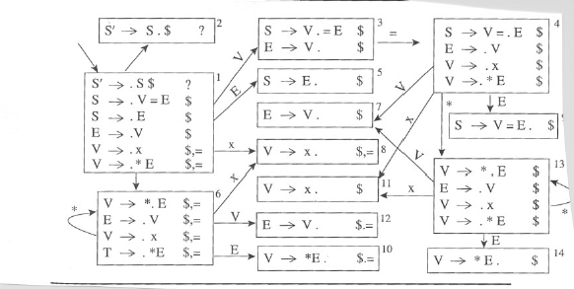

9. *** Given the grammar below construct the LR(1) sets of items. (Grammar emailed tonight)

