CSCE 101 Lab 9 – Get the Gold, more sprites, and the clock
App Inventor Tutorial Get the Gold + Lists + Foreach

Academic Honesty
- The work you turn in is to be your work, not copied from someone else, from the web, or generated by a program.
- Never allow anyone access to your files.
- Never give anyone your password.
- Never share your USB memory or email your files to anyone else.
- Never give anyone a printed copy of your file or an electronic copy.
- Never allow anyone to copy your work.

Problem Statement
You will save the completed assignment in your 101Labs folder.
It is important that you name your files exactly the name given. This is what is looked for during grading.

The Get The Gold tutorial guides you through making a game where there is a pirate ship going after gold. The issue with the way the lab is written is that it involves a lot of nearly identical blocks – there is a better way involving foreach loops, which take lists as input (you will end up deleting a lot of old blocks).

Initial Setup
- You are going to follow the instructions for the Get The Gold tutorial. Name your app project Lab9_XY, where XY are your initials.
- Open the Get the Gold Tutorial (Direct Link: http://explore.appinventor.mit.edu/ai2/get-gold)
- Note: Follow the tutorial carefully. In particular, name your components and variables the same as in the tutorial so the following instructions make more sense.
- Add a label with your name to app.
- Double the speed of the ship: It’s too slow to really get the gold. You end up waiting for it to come to you which isn’t particularly fun.

Extensions
- Please read the directions carefully. We just want the final version of the lab, with all the extensions.
- Do not have more than one event handler of the same type for the same UI component event.
- High-Level Explanation:
  - Having completed the tutorial, you may have wondered if there was a better way to effect many components with one set of blocks instead of writing code for ImageSprite2, ImageSprite3, etc. individually.
  - The way the tutorial does it is not the way it is done in practice. Some programmers might even consider it wrong, not just inefficient. Instead, for this tutorial, we can use lists of components and loops, which can run code for every item in a list.
  - We are going to introduce several new Blocks and programming concepts in this lab. Each numbered step will have its own explanation portion. It is probably most efficient to just read it at the beginning, figure out the blocks, and then make sure you understand by the time you move on to the next step.
- (Any) ImageSprite.Visible block and PirateSprite.CollidedWith.
  - Explanation: So far, every time we change an object we reference that object directly by going to My Blocks, picking the individual component we want, and writing code that can only affect that component. If we have to affect many components, five gold ImageSprites in our case, we have to do the same thing to every sprite individually and by name. The (Any) ImageSprite block will apply to any ImageSprite, but it has to be given a reference ImageSprite to apply a change to.
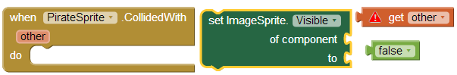
  - We are going to modify the PirateSprite.CollidedWith event handler, which has five ifs in it. All that code is going to be replaced with the above blocks. The tutorial version of the code does not use the “other” parameter that is given to the CollidedWith event handler, which lets you know which Sprite the PirateSprite collided with and checks for all possible collisions, rather pointlessly.
    - When the PirateSprite collides with any of the other sprites (the gold) we want to make that gold disappear (set the Visible property to false). We want to do the same thing for every gold so this is a natural case for using the (Any) ImageSprite block.
    - Delete (drag to the trash) everything currently inside the CollidedWith.
    - Under Any component->Any ImageSprite, drag out a set ImageSprite.Visible. Note that it takes two arguments: “of component” is which image sprite we are changing and “to” is the value we are changing it to (true or false).
      - value other can be found under by hovering your mouse over the other parameter
      - logical false is under Built-In->Logic.
    - Notice that we didn’t need ifs with their conditional statements and all because the parameter has all the information we need and the code is much clearer.

- Replacing ResetButton code using Lists, foreach, and (Any) ImageSprite.Visible.
  - Explanation: In Step 4, where we use the (Any) ImageSprite.Visible is obviously better since there is no pointless, error-prone, repetition and it’s fairly straightforward once you understand how the (Any) ________ blocks work. We’re going to expend a little effort in this step which will pay dividends in step 6.
    - We need a list of the components we want to effect – all the gold ImageSprites
    - We will use a foreach loop to set (Any) ImageSprite.Visible to true make all the gold visible again.
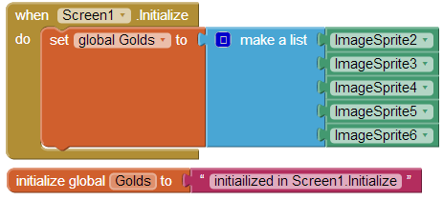
Figure 1:Blocks for 5b&c
  - Define a Golds variable and give it an initial value of “initialized in Screen1.Initialize”, letting you know it’s garbage and where it is initialized.
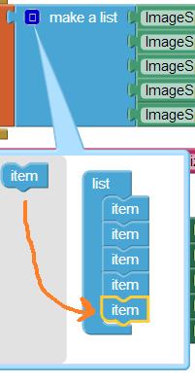
  - We want the Golds variable to hold a list of all the gold ImageSprites (remember that ImageSprites are a type of component). You cannot access components, or get their blocks until the application is finished loading; assigning the text (“…”) actually happens earlier. When the app is done loading, we need to set Golds to a list of the components. This can be done using the Screen1.Initialize event handler, which is called when the Screen is done loading. You may have to reload the app in the emulator to see the effect (Initialize only happens when the app is first loaded).
    - Drag out a Screen1.Initialize Event Handler.
    - We’re changing the Golds variable so drag out a set Golds by hovering over the “Golds” in the initialize global Golds to block and attach it inside the Initialize.
    - We’re making a list so what we want is a make a list block from Built-In->Lists and attach it to the set Golds.
    - make a list doesn’t automatically expand as we add items so we need to actually make it accept five inputs (ImageSprite2,3…6). See image to the right. Hold your pointer over the dark blue square in make a list. Drag items from the left side to the right until you have 5 items in the list.

    - Drag each ImageSpriteX out from ImageSpriteX->ImageSpriteX , where X is a number and attach each to the make a list (the ImageSpriteX block will probably be the last block in the list, you may have to scroll down).

  - Now, we want to actually do something to each item in the list.
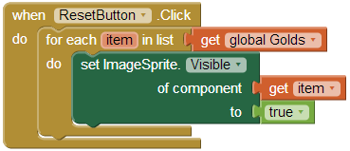
    - Delete everything in the ResetButton.Click event handler.
    - We need a foreach block to run code for each item in the list. foreach runs its do section for each item in the list, the value of each item will be stored in a variable referred to by the name in the “variable” socket, accessible in My Blocks->My Definitions.
      - Drag out a foreach (Control->foreach) and attach to ResetButton.Click.
      - Drag out a get global Golds value block and attach it to the “in list” socket of the for each.
      - We want to change every gold item so that its Visible property is true, so attach the set (Any) ImageSprite.Visible, a value item, and a logical true, as above.
    - This is your first “loop”. In the background, App Inventor is going down the list one by one and calling the “do” code for each item in the list. The “do” code is getting repeated for each item and could be thought of as being in a loop similar to a DVD or movie that starts over from the beginning once you get to the end where the “do” code is the movie in our simile.
- Test your code: you might need to restart to get Screen1.Initialize to trigger.

- Now, modify the Clock1.Timer event handler so that it uses a foreach loop over the Golds list.
  - Explanation: Similar to ResetButton.Click, we want to do exactly the same thing to every gold ImageSprite, so we use a loop and a (Any) ImageSprite.MoveTo to change the locations of the gold.
  - Replace everything in Clock1.Timer with a foreach (variable=”gold” or “item”, in list = get global Golds). It might be beneficial to keep one ImageSpriteX.MoveTo block around for reference.
  - Now, we need to use the (Any) ImageSprite.MoveTo to change each gold when the loop is called. The idea is identical to the Moving the Coins section of the tutorial.
  - See how much cleaner and shorter it is with looping over a list versus hard-coding for every single gold? It’s also not just about making the programming easier – what if the items in the list are created “on the fly”, by the user or the program after the program is written?
- Update the images so that the PirateShip is cocky and the golds are awards. Use the files from here: http://cl1.cse.sc.edu/101/Lab9Assets.zip

- Change the text of the Reset button so that it says “Next round”.
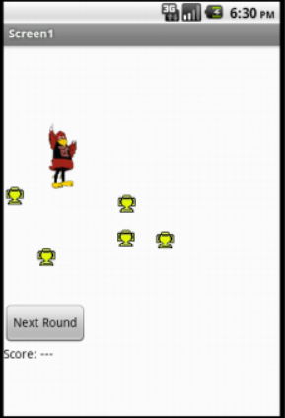
- Keeping score without variables.
  - After the Reset button, add a Horizontal Arrangement
  - To the Arrangement add two labels, the first with “Score: ” as its value
  - Rename the other label to something like “LScore” and give it a starting value of “0”.
  - In Blocks Editor add the code to increment the value stored in the Score label’s text property in the CollidedWith event handler.
  - Note: Collisions don’t happen with invisible Sprites so we don’t need an if here.

Submitting your file
- Download your final version of Lab9XY and save it under the 101Labs folder on X:. Rename it if you did not add your initials (F2 or right-click file->Rename).
  - We will grade it if we see this downloaded file (.aia file) in your directory so don’t download until you are done.
  - We cannot see any of your work until you have downloaded the file to this directory so you haven’t submitted it until it is in X:\ .
  - If you cannot find the file downloaded then, in the browser window, Ctrl-J to get to the default download location. You should then be able to click on “Show/Open in folder” to see the file in its folder. (“Ctrl-J” means hold down Ctrl and tap J, then release Ctrl)

E.g. what if you write essentially the same code 10 times and then have to make a change? Errors are more likely.

