CSCE 101 Lab 6 – Paint Pot and the Canvas
App Inventor Tutorial PaintPot + Extension: using ifs and Canvas features

Academic Honesty
- The work you turn in is to be your work, not copied from someone else, from the web, or generated by a program.
- Never allow anyone access to your files.
- Never give anyone your password.
- Never share your USB memory or email your files to anyone else.
- Never give anyone a printed copy of your file or an electronic copy.
- Never allow anyone to copy your work.

Problem Statement
You will save the completed assignment in your 101Labs folder.
It is important that you name your files exactly the name given. This is what is looked for during grading.

Pre-Lab
- You are going to follow the instructions for the PaintPot tutorial. Following tutorials is common when you are first getting used to a new set of tools.
- First, let’s open the tutorial off of the App Inventor site. Go to http://appinventor.mit.edu/, click Explore, then Tutorials, and then follow the link to the Paint Pot. (Direct Link: http://appinventor.mit.edu/explore/ai2/paintpot-part1.html)
- Name your app project Lab6_XY, where XY are your initials.
- Note: Follow the tutorial carefully.
- Add a label with your name and section number to app.

In-Class Assignment(Lab6_XY)
- Changing the picture
  - Add three or more images (not too many) to the Media pane of the Designer. You would use an ImagePicker if you were actually deploying to a phone to pull from the Gallery. You can pull images from images.google.com (keep it PG-13).
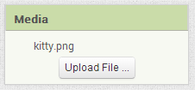

  - Changing Background Images: Add a ListPicker to the Designer.
    - Change the name to something more descriptive.
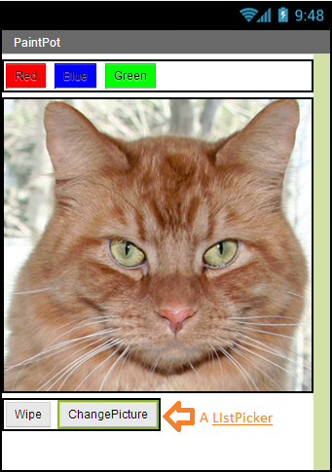
    - Change the text on the ListPicker
    - Add a comma-separated list to the ElementsFromString property in Designer, using the image names (including extensions like “.jpg”, “.png”) you added to the Media pane in step 7.
    - We are running out screen space so it would be good to put the picker with the Wipe button (horizontally). Do so – you did it in the Tutorial portion with the color buttons.
    - Switching to block editor, make the ListPicker change the background image of the DrawingCanvas: Drop the ListPicker’s AfterPicking event handler on the Blocks Editor. Make it set the DrawingCanvas’ background image to ListPicker’s Selection property.
    - Test it! If you do not have emulator running already, you should.

- Updating the UI for a different drawing tool: We already have a pencil- it draws where we drag our pointer/finger. If we touch the screen we get a larger dot. Now, we want a way to draw straight lines. Add buttons for Pencil and Line, both inside a Horizontal Arrangement. (We don’t need one for the dots).
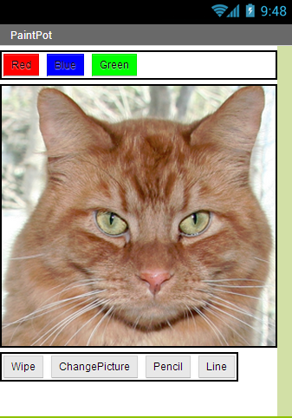

  - Change the text of the buttons so it makes it clear what the button does (“Pencil” and “Line” are fine).
  - In Blocks Editor, define a global variable (Built-In->Variables->initialize global name to.
    - The purpose of this variable is to store the current tool selected, so change “name” to something like “tool”. There will only be one variable for both tools.
    - Attach a text ( " " ) block to it to make it start with a value of “pencil”.
  - Make the pencil and line buttons change the value of the tool variable when they are clicked so that when the user is moving their finger around the screen we know what we are supposed to do in the draw line and draw pencil code.

- Using the variable to know when to Draw With a Pencil: We have the code to draw with a pencil but since we are going to also draw a line we need to draw the pencil line when the tool variable is “pencil” and not when it is anything else (“line”, e.g.). This naturally calls for an if (Built-In->Control).
  - Move all the code inside the DrawingCanvas.Dragged do area inside the then area of an if.
  - Use an equality test ( = , under Built-In->Logic ) for the test – comparing the value of the tool variable to a text with “pencil”.
  - Test it. Make sure that when you press the Line button, pencil-drawing is disabled and that it returns when you click the Pencil button.

- Drawing Straight Lines: This is a little trickier than the pencil code. The issue is that you need to use two event handlers – DrawingCanvas.TouchDown and DrawingCanvas.TouchUp. TouchDown stores where the user started touching on the screen. TouchUp draws the line when the user picks up their finger.
  - Don’t worry about an if yet.
  - Make TouchDown store where you began in two, new global variables. Use the x and y parameters as the locations.
  - Make TouchUp use DrawingCanvas.DrawLine using the values the two, new global variables and the x and y parameters of TouchUp.
  - Test it.

- Drawing Lines only when the Line button was pushed last: Use an if like you did in step 3 to only draw lines when you should (when the tool variable is set to “line”).

- Test Your App Thoroughly

Submitting your file
- Download your final version of PaintPot and save it under the 101Labs folder on X: Rename it if you did not add your initials (F2 or right-click file->Rename).
  - We will grade it if we see this downloaded file (.aia file) in your directory so don’t download until you are done.
  - We cannot see any of your work until you have downloaded the file to this directory so you haven’t submitted it until it is in X:\ .
  - If you cannot find the file downloaded then, in the browser window, Ctrl-J to get to the default download location. You should then be able to click on “Show/Open in folder” to see the file in its folder. (“Ctrl-J” means hold down Ctrl and tap J, then release Ctrl)

