CSCE 101 Lab 5 – What's the If?
App Inventor If Practice

Academic Honesty
- The work you turn in is to be your work, not copied from someone else, from the web, or generated by a program.
- Never allow anyone access to your files.
- Never give anyone your password.
- Never share your USB memory or email your files to anyone else.
- Never give anyone a printed copy of your file or an electronic copy.
- Never allow anyone to copy your work.

Problem Statement
You will save the completed assignment in your 101Labs folder.
It is important that you name your files exactly the name given. This is what is looked for during grading.

In this lab we are going to practice writing if statements. You will write eight if statements, five of which will be done independently. You will have three screens: Screen1 (for numerical ifs), TextIfs, and EasterEggIfs. Rename your buttons and TextBoxes as appropriate.

User Interface (UI)
- We are providing the UI.
  - Download from (Ctrl-Click the link): http://cl1.cse.sc.edu/101/Lab6_XY_UI.aia
  - If that does not work, click this backup link:
https://drive.google.com/file/d/0B9sKadoJpcULaUpyZWh1b3JqQW8/view?usp=sharing
A window will pop up in your browser. Click the  download symbol top middle to actually download the Lab6_XY_UI.aia file.
- Navigate to the downloaded file and rename it so that it doesn’t have _XY_UI at the end but, rather, your initials.
- In App Inventor, Click Projects -> Import project (.aia) from my computer and navigate to where you downloaded it and then select the file to import.
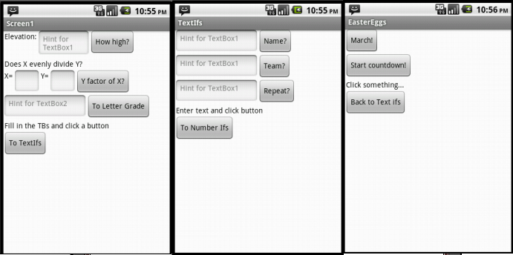
  - There are no ListPickers, so all things that look like Buttons are actually buttons.
  - Each screen has one Label for output.
  - Load the emulator when you are done with the UI; you want test each if as you make it -- errors are easiest to fix for code you wrote the most recently.

Numerical Ifs
- The code for the first if, which tells you whether you're very high or in the danger zone (for mountain climbing) based on elevation.
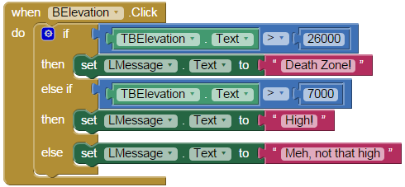
- Build the code to tell you if number X is evenly divisible by Y. Output a message to the message label. Use remainder. Clear the “Hint” properties of X and Y.
- Build the code to tell you what letter grade a number grade corresponds to. Don't worry about rounding. Only worry about whole letter grades, i.e. A, B, C, D, and F. A is 90+, B is 80+ but not an A... use an if,else if..., else.

Text Ifs
- Build the following code, which will give responses for a few names and transfer you to the EasterEgg Screen if you type in your name (probably not BillyBob, substitute your name).
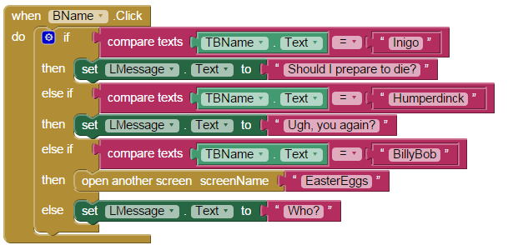
- Write the code to tell the user what team they are on based on their last name. Names that begin with A-G are Team 1; H-M are Team 2; N-S are Team 3; and T-Z are Team 4. You should convert all last names to uppercase (upcase) before using a compare texts.
- Write the code for the last if such that when the button is clicked it compares the current value in the text box to the previous value entered and tells you whether it is the same or different from what was previously entered, e.g.:
  - "chicken"<Click>
  - output:"Does not match"
  - "goat"<Click>
  - output:"Does not match"
  - "goat"<Click>
  - output:"Texts match!!"
  - "chicken"<Click>
  - output:"Does not match" (only looks at the last one)

You will need a global variable; initialize it to a text with random characters. You need to set the variable after you do the test.

Easter Eggs
- Note that there is a clock in the EasterEggs Designer screen. We need the timer part of the clock. The TimerEnabled checkbox is unchecked. Also note that the output label is named “LMessage” here.
- Do the following code for the March Button:
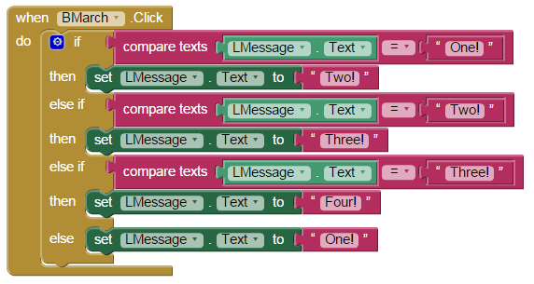
To make sure you understand how it works, ask yourself why the “One!” case is last, in the else?
- Countdown timer:
  - Make it so the countdown button starts the timer (in blocks, set Clock1.TimerEnabled to true).
  - Make no other modifications to the countdown button’s click event handler.
  - You need to drag out and add to Clock1.Timer, the event handler for when the timer fires. This is where your if logic belongs.
  - In Clock1.Timer:
    - Make it so that it counts down from 3 to 1 and that when you go lower than one, it displays “Liftoff!”.
    - You will want to make the messages slightly different from the Marching ones to make the two not interfere with each other.
    - When you reach liftoff, disable the timer (Clock1.TimerEnabled to false).

Submitting your file
- Download your final version of the lab and save it under the 101Labs folder on X: Rename it if you did not add your initials (F2 or right-click file->Rename).
  - We will grade it if we see this downloaded file (.aia file) in your directory so don’t download until you are done.
  - We cannot see any of your work until you have downloaded the file to this directory so you haven’t submitted it until it is in X:\ .
  - If you cannot find the file downloaded then, in the browser window, Ctrl-J to get to the default download location. You should then be able to click on “Show/Open in folder” to see the file in its folder. (“Ctrl-J” means hold down Ctrl and tap J, then release Ctrl)

If the text makes no sense, then go watch The Princess Bride.

