CSCE 101 Lab 4 – Wildcat Smasher
MoleMash variant

Academic Honesty
- The work you turn in is to be your work, not copied from someone else, from the web, or generated by a program.
- Never allow anyone access to your files.
- Never give anyone your password.
- Never share your USB memory or email your files to anyone else.
- Never give anyone a printed copy of your file or an electronic copy.
- Never allow anyone to copy your work.

Problem Statement
You will save the completed assignment in your 101Labs folder on your X: drive (X:\101Labs\).
It is important that you name your files exactly the name given. This is what is looked for during grading.

Tutorial Section (Pre-Lab)
- You are going to follow the instructions for the MoleMash tutorial with following changes:
  - Important: When starting your project, do not do the Tutorial in Screen1. Create a Screen1 for Lab4 like you did for Screen1 in lab 3 -- which has buttons you can click to get to either the Fahrenheit or Grade Calculators for each of the separate Calculator screens. Do the Molemash Tutorial in a separate screen (name it "MoleScreen" or something similar). Just make sure Screen1 has:
    - A short message, including your name
    - A button that will take you to the Molemash screen and the code in Blocks Editor to actually do it.
    - You can wait to add a button for the final part of lab 4.
  - Name your file “Lab4_XY”, where ‘X’ and ‘Y’ are your initials.
  - Change the TimerInterval property to 1000 to start with, not 500.
  - You don't need to do the “variations” part.
See following pictures:
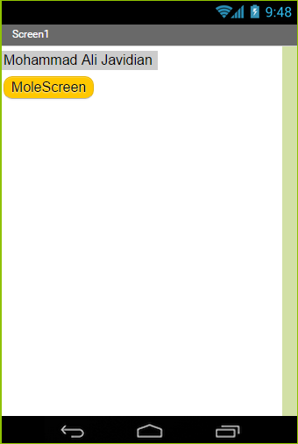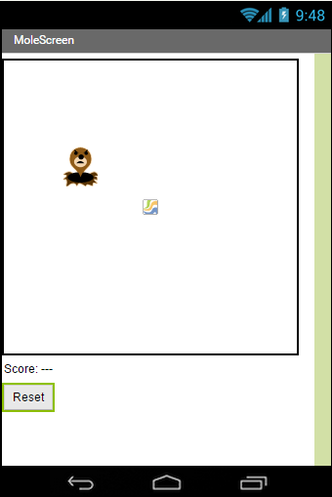
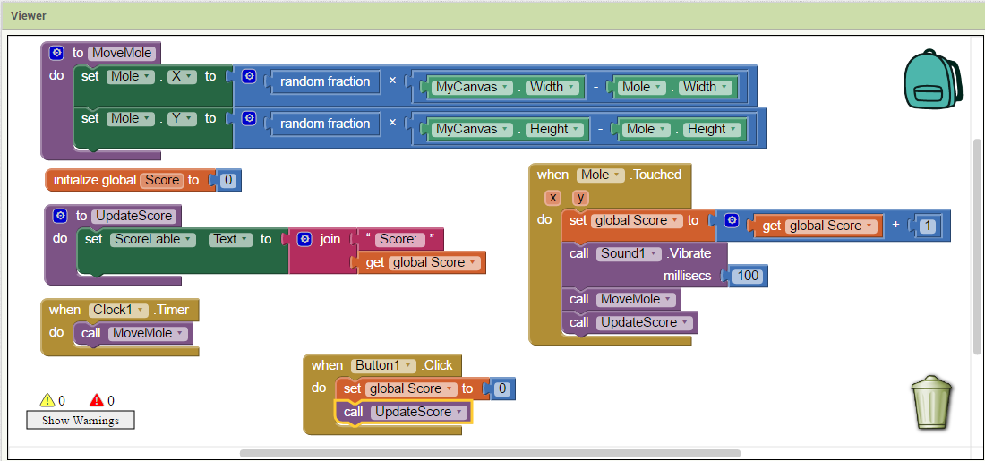
- App Inventor site: http://appinventor.mit.edu/.
- MoleMash direct link: http://explore.appinventor.mit.edu/ai2/molemash

