CSCE 101 Lab 4 – Rival Smasher
MoleMash Variant

Academic Honesty
- The work you turn in is to be your work, not copied from someone else, from the web, or generated by a program.
- Never allow anyone access to your files.
- Never give anyone your password.
- Never share your USB memory or email your files to anyone else.
- Never give anyone a printed copy of your file or an electronic copy.
- Never allow anyone to copy your work.

Problem Statement
You will save the completed assignment in your 101Labs folder on your X: drive (X:\101Labs\).
It is important that you name your files exactly the name given. This is what is looked for during grading.

This game will be like MoleMash except that every time the sprite pops up it should be the image of either your (Good) team mascot or the Rival team mascot.
The idea for this game is that when the game clock is running down, the player must keep smashing the rival mascot to stay alive. The game plays like MoleMash except:
- The game should get progressively harder while the player avoids running out of life. The ImageSprite moves faster and faster every time there Rival’s mascot is smashed.
- Every time the clock fires the player’s life should go down 1.
- The Life (formerly score) should start at 30.
- If the player hits your team’s mascot (good team), their life should go down by 5.
- Every time the player hits the rival mascot, the life should go up by three and the TimerInterval of the clock(which should start at 1000) should be multiplied by 0.95.
- Since this is a significant modification of Molemash, it may be a good idea to keep the final code up from the tutorial when you’re doing this: MoleMash (scroll to the bottom).
- You need to pick two college teams, preferably rivals. You need to pick one team as the team you’re rooting for (called Good, here) and another poor team you’re going to smash the Rival team.
- Create another screen in the app you made for the pre-lab; name it “RivalSmash” (since this is a Rival-smashing game).
- In that screen load these images (NOTE that there is only ONE ImageSprite – we will change the image back and forth):
  - You need to go online and download the images for teams Good and Rival. They will be used like Molemash, so they need to be fairly simple.
  - images.google.com is recommended – searching for “Good mascot” or “Rival mascot” is probably best.
    - Click the image you like. Square images work better.
    - Click view image (not all may be viewable)
    - Right click on the image and click “Save image as…”
  - Add the Canvas, Reset Button, and an ImageSprite (rename to Mascot). Set the ImageSprite's width and height to 40-by-40.
- Create another Screen, called “GameOver” or something similar and load this image into it: https://drive.google.com/open?id=0Bx7jqgf_HyMlQ0VDb1YyeUllR1U
  - Drag out an Image component in Designer and set its:
    - Picture to gameoverthumb.jpg
    - width and height to 300 pixels
  - Add a “Back to Start” button that will take you back to Screen1.
- Go back to the _Rival_smash Game Screen
  - You need to recreate MoleMash except with these changes:
    - It would make sense to name everything “Mascot” instead of “Mole”, obviously (the ImageSprite and the Clock, in particular, but also the procedure names).
    - “Score” should now be “Life” as well.
  - Every time the clock's timer fires do the same stuff as in MoleMash except
    - the life total should go down by one (1), which didn’t happen in MoleMash
    - call UpdateLife (formerly UpdateScore)
    - You also need to see if the game is over. The game is over when the player’s life is less than 1. Here’s the code for the if you will need: 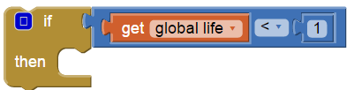
    - If the game is over than you need to go to the GameOver screen. Note that sometimes the emulator won't show the image when you change screens.
- In the MoveMascot (not "MoveMole") procedure, in addition to choosing a random location, change the picture randomly by setting the Mascot imageSprite’s Picture field to pick a random item, make a list, like in lab 1, followed by the text blocks (“ ... ”). The image file name should go in the “…” (e.g. Rivalmascot.jpg).
- When the ImageSprite is touched, you need to use 2 ifs or a single if/else, which can be found in the Control drawer. The code to see if the Mascots current picture is the Good teams’s (where team is A is, obviously Univ. of South Carolina – the text (“” block) for yours will likely be different) is :
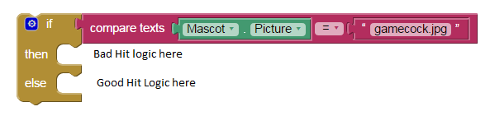
The hot pink blocks are from the Text Drawer.
- If Good mascot is hit, then reduce life by 5
- If the Rival mascot is hit then:
  - life goes up by 3
  - the game should speed up, i.e.:
set MascotClock.TimerInterval to MascotClock.TimerInterval × 0.95.
- For both a and b, call UpdateLife and then call MoveMascot

- The reset button should reset the life to 30 (not to 0, since that wouldn't be very fun).

Submitting Your Code (Generic Instructions)
- ​Open "My Projects" in upper right of the App Inventor Webpage
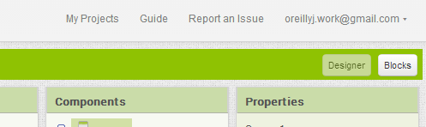

- Put a check next to the project you want to download (you can only download one at a time). Download the modified version, if you have multiple copies.
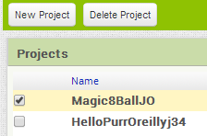
- Project->"Export selected project (.aia) to my computer"
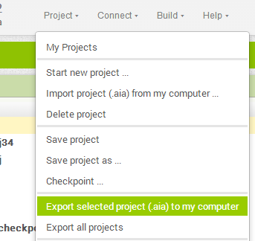
- The file will download so go, in Chrome, to the download location by clicking the arrow next to the file name at the bottom of the screen and selecting "Show in folder".
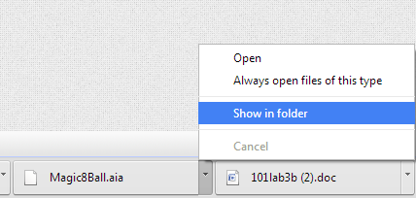
- Move the _______________.aia file to your X:\101Labs directory for grading.
- Important: make sure you have only letters and numbers in the file name -- there should not be a " (1).aia" at the end. Right Click, Rename the file to get rid of the space, number, and parentheses. If you haven't already, you must add your initials to the end of the file name, before the ".aia" extension. Your lab instructor may deduct 5 points if you fail to do either of these steps.

Using images off of the internet is fine if you aren’t distributing your work, otherwise you need to worry about licenses.
http://olistor.com/cute-skull-and-crossbones-clip-art-photos (CC license)
A file will have an extension (.jpg, .bmp, .png, or a few others). If you don’t see that part of the file name, in Windows Explorer, click Organize -> Folder and Search Options -> View [Tab] -> uncheck hide extensions for known file types

