CSCE 101 Lab 3

Calculators: TextBox Input, Labels , Output, Multiple Screens

Academic Honesty
- The work you turn in is to be your work, not copied from someone else, from the web, or generated by a program.
- Never allow anyone access to your files.
- Never give anyone your password.
- Never share your USB memory or email your files to anyone else.
- Never give anyone a printed copy of your file or an electronic copy.
- Never allow anyone to copy your work.

Problem Statement
You will save the completed assignment in your 101Labs folder.
It is important that you name your files exactly the name given because this is what is looked for during grading.

In this lab you will be creating an app with a start screen and two other screens, each with a different calculator you can use. The first will be a simple temperature converter calculator. The second will be a calculator that can be used to compute your grade.

You will be following the instructions below in this assignment. We will not be using a tutorial for this lab.

Lab Assignment
- Create the User Interface – what the user interacts with.
  - First, let’s open the App Inventor site. Go to http://appinventor.mit.edu/, and click on the Invent button to pull up App Inventor.
  - You will need to go to My Projects, go to New, and create a new project called “CalculatorsXX” where XX is your initials. Your lab instructor may deduct 5% if you forget your initials.
  - Change the “BackgroundColor” or “BackgroundImage” property and the “OpenScreenAnimation” property of Screen1. Set them to something you like.
  - Drag over a Label and Two buttons and style them at least as well as Screen1 (below step j) which uses a larger FontSize on the Label and a rounded Shape on the buttons. You can change the Text by changing the Text property.

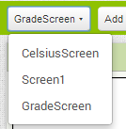
  - Now, create two more screens with the  button. Name them similarly to “GradeScreen” and “CelsiusScreen”.
  - Change back to Screen1 with the button to the left of the “Add Screen …” Button by clicking on it and selecting “Screen1”.

  - Switch to Blocks with the button in the upper right of the screen: 
  - In blocks editor you need to make each button open the correct Screen using Built-In->Control->open another screen . The value should be just a text block ( ) which is the first block under Built-In->Text. Set its value to the name of the Screen you want to change it to (named as in step f).
  - In this screen you need to add a Label with the words “Celsius:” and then a TextBox, side by side (so you will use a horizontal arrangement))
      - Check the Text Box Property for Numbers Only
  - Then add a button, two labels in a horizontal arrangement, and then another button. Change the name of the second label to something like “FahrenheitOut” using .
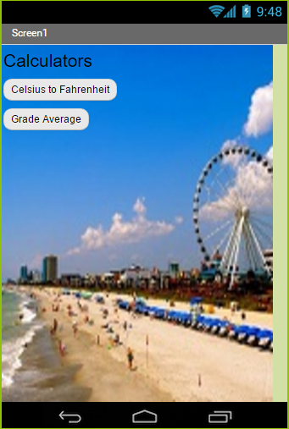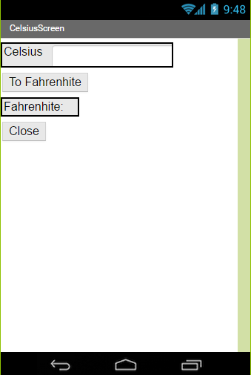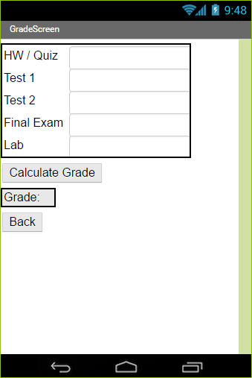
  - Finish styling the Celsius Screen as above and go ahead and do the GradeScreen. Pointers for the GradeScreen:
    - You can use 6 HorizontalArrangements (there is an invisible label beside the “Grade” label) or 1 TableArrangment (2 columns, 5 rows) and 1 HorizontalArrangement.
    - the TextBoxes (not the labels) so that you can tell which value was actually entered when you are in the Blocks window.
  - Test it.

- Create the code – what makes it do stuff
- Switch to the  and then go into the window.
- Drag out the blocks so that when the “To Fahrenheit” button is clicked, the value is stored in the output label (which is invisible in the UI screen to start with, but where the 212 is in the above picture of the UIs)
    - Set Fahrenheit to ( (Celsius * 9) / 5 ) + 32 Note that set… is a block, most of the rest are under Built-In->Math. Celsius should be the Text property of the TextBox.
    - Be careful of order of operations (the above parenthesization is correct).
- Define the “Back” buttons in GradeScreen and Calculator Screen by just calling the close screen block in the button’s event handler (Built-In->Control->close screen).
- Finish the GradeScreen blocks to actually calculate the Grade. Use the following equation:
Grade = (Homework and Quiz Average)*.1 + (Lab)*.3 + (Test1)*.2 + (Test2)*.2 + (Final)*.2
Mind your order of operations (inner blocks get processed first). The multiplications go inside the addition (click the blue square to add more spots to the addition for each multiplication term).

Testing Your Code

- Please test your work to make sure it works as intended.
- If you haven’t connected to the emulator, do so now.
- Start in Screen 1 and make sure you can go to each screen and Back/Close takes you back to the start screen.
- Make sure the Celsius to Fahrenheit converter works (e.g. 100C = 212F, 0C=32F)
- Test the Grade Calculator thoroughly: All 100s should be 100, all 100s but a 50 on test1 with all the other scores at 100 should be a 90 (since tests are worth 20%), etc.

Got time left? (Pre-Lab for next time)
Your lab instructor should have the lab4 pre-lab linked off of their webpage. You may begin the Pre-lab or just read it ahead of time.

Submitting Your Code (Generic Instructions)
- ​Open "My Projects" in upper right of the App Inventor Webpage
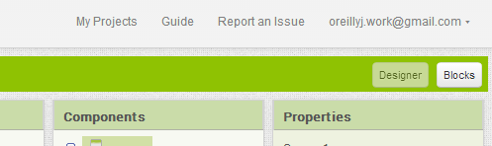

- Put a check next to the project you want to download (you can only download one at a time). Download the modified version, if you have multiple copies.
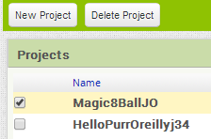
- Project->"Export selected project (.aia) to my computer"
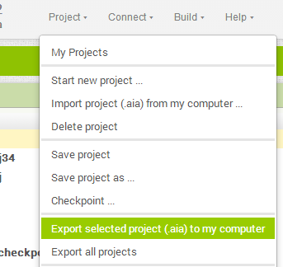
- The file will download so go, in Chrome, to the download location by clicking the arrow next to the file name at the bottom of the screen and selecting "Show in folder".
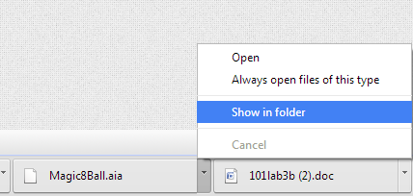
- Move the _______________.aia file to your X:\101Labs directory for grading.

