CSCE 101 Lab 2
Hello World and Color

Academic Honesty
- The work you turn in is to be your work, not copied from someone else, from the web, or generated by a program.
- Never allow anyone access to your files.
- Never give anyone your password.
- Never share your USB memory or email your files to anyone else.
- Never give anyone a printed copy of your file or an electronic copy.
- Never allow anyone to copy your work.

Problem Statement
You will save the completed Project in your 101Labs folder.
It is important that you name your files exactly the name given because this is what is looked for during grading.

- You will be using steps in the lab problem to create a program that can accept text input from the user and make use of the information. You will also change the colors of various items on the page using buttons.
- You will name the project “HelloWorldXY” where XY are your first and last initials.

The Layout:
- First, grab a Horizontal Arrangement from the Layout Palette and drag it onto the viewer
  - In the Components part of the screen, select the layout and then click the button that says Rename.
  - Type the new name “StudentInfo” and hit OK
- From the User Interface Palette, grab a label and drag it into the StudentInfo Horizontal Arrangement.
  - Rename the label to NameOfStudent
  - In the Properties section of the page, change the Text property to be your full name.
- Drag out another label to put in StudenInfo
  - Rename it to SectionNumber
  - Change the Text property to say “101-0X” where X is your section number
- Get another label, but drop this one outside the StudentInfo
  - Rename it to GreetingText
  - Set Text to be “What is your name?”
- Grab a second horizontal arrangement and place it below the GreetingText label.
  - Rename it to NameSection
- Grab a TextBox from the User Interface palette, and drop it inside NameSection
  - Rename To “NameEntry”
- Grab a Button from the User Interface palette and drop it next to NameEntry inside of NameSection.
  - Rename the button to “EnterButton”
  - Change the Text property to “Enter”
- This time, grab a Vertical Layout and place it below the ‘’NameSection” label.
  - Rename to ColorSection
- Grab 3 Buttons and place them inside of ColorSection
  - Name them “FontColor”, “BGColor”, and “Reset” respectively.
  - Change the Text properties of each to something that you think appropriate.
The Coding (Where we make stuff happen)
- Make sure to start the emulator in order to test your project. (Connect->Emulator)
- Click on the Blocks button in the upper right corner of the screen. Scroll over if you can’t see it.
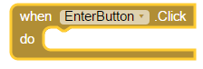
- Look down under the list of blocks until you see the EnterButton item. Click on it to pull up the list of associated code blocks. We want to have something happen when we click on the EnterButton, so we will drag this block out. Be very careful that you only ever drag one event handler of the same type from the same component – duplicates will cause errors (a triangle will appear in the upper left of the block.

- When the button is clicked, we want to change the GreeetingText to be the phrase “Hello, XXXXXX!” where XXXXXX is whatever was typed into the NameEntry

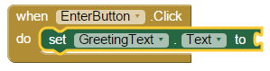
  - Lets break this down: First, we are changing the text value of GreetingText. To do this, select GreetingText under blocks, and drag the following block into the slot in our when EnterButton.Click block. This allows us to change the Text property of GreetingText.
  - What do we want to change the text to? The combination of two pieces of text. To do this, go to the built-in section of blocks and select Text. You are looking for a block that says “join” on it, with a puzzle piece sticking out on the left side. That puzzle piece will fit into the hole on our “set GreetingText.Text” block.
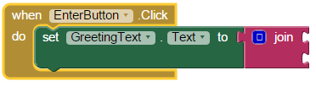
  - The two pieces of text are a phrase, and the contents of the text box. While we are in the Text area, grab the block that has quotes and a spot to type something, and drag it onto the first puzzle gap in the join block. Type inside this new block “Hello, “ (make sure you include the space after the comma)
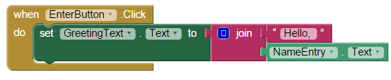
  - Then go to the NameEntry and find the light green block that says “NameEntry.Text”, drag it out and put it in the second slot of join.
- We now have 3 other buttons that we need to do something with. You might guess what some of the purpose of the buttons is from the names, which is why we named them what we did.
  - A note: when you want to change a property of a component, you are looking to use a dark green box that contains the word “set”. If you are trying to find the existing value of the component property, you want a light green block that just has the Component.Property
- The first button needs to change the font color of GreetingText. Therefore, using the When Button.Click for the first button, you need a “set GreetingText.TextColor” block.
  - Instead of accepting text, this time you need a color from the built-in blocks. You can select a color from Colors on the left side of the screen under Built-In.
- The second button needs to change the background color of the entire screen. To change screen properties, you need to click on Screen1 under blocks. As you might expect, you need to get the “set Screen1.BackgroundColor” block.
- Finally, the reset button will undo all those changes that we made. Since it is possible to have changed both the font and the background color, you need to do multiple things inside your Click block:
  - Set the GreetingText.TextColor back to Black
  - Set the Screen1.BackgroundColor back to White
- Submitting your files:
  - ​Open "My Projects" in upper right of the App Inventor Webpage
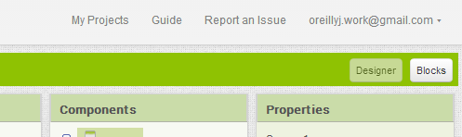
  - Put a check next to the project you want to download (you can only download one at a time). Download the modified version of your app, if you have multiple copies.
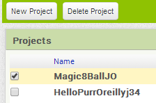
  - Project->"Export selected project (.aia) to my computer"
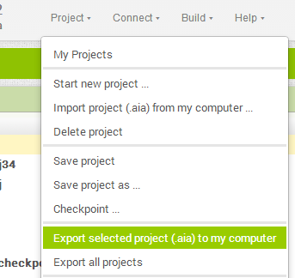
  - The file will download so go, in Chrome, to the download location by clicking the arrow next to the file name at the bottom of the screen and selecting "Show in folder".
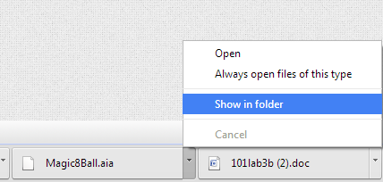
  - Move the _______________.aia file to your X:\101Labs directory for grading (or upload).

