TUTORING
Spring 2021 tutoring options for the following courses include:
- In-person by appointment in
Swearingen and Thomas Cooper Library
- In-person drop-in in Thomas Cooper Library
- Online by appointment and drop-in

BMEN 212, 290
CSCE 102, 145, 146, 206, 211, 212, 215 CSCE 240, 350, 355, 390, 416
ECIV 111, 200, 220, 320
ELCT 102, 221
EMCH 200, 201, 290, 310, 332, 354, 360
MATH 115, 122, 141, 142, 241, 242, 344
CHEM 111, 112, 141, 142, 333, 334, 350
PHYS 201, 202, 211, 212
BIOL 101, 110, 302
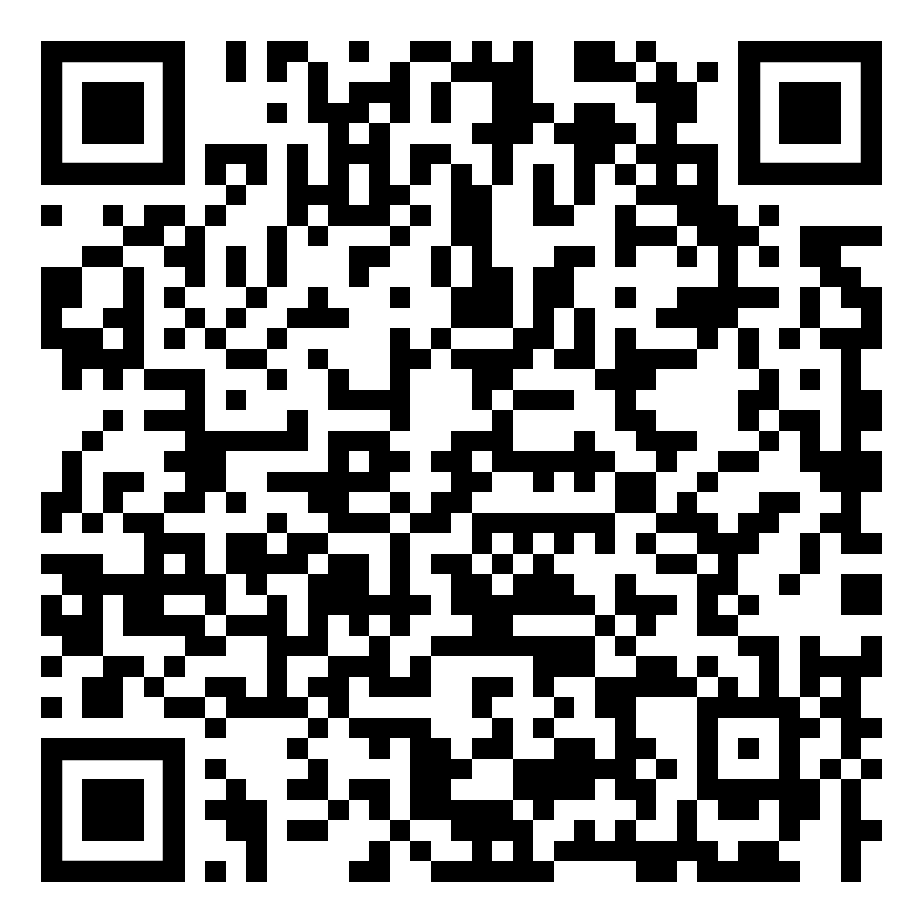
SCAN HERE to
- Find out what options and times exist for your course
- Make an appointment for Swearingen or Thomas Cooper Library
- Access login for online options
- Access full list of supported courses

If you need help with an Engineering or Computing course not supported by Student Success Center tutoring this semester, you may email mansfien@email.sc.edu to see if a Tau Beta Pi volunteer tutor is available to help.

