CSCE 102 Honors — Image Maps and layouts

General information
- Always bring your book and lecture notes to lab.
- Use clean indentation so your code will be easy for you to read and easy for your instructor to read.
- Include the closing tags when you enter the opening tags so you will not forget them.
- Always maintain backup copies of your work. Always work on your X drive and copy your work to your flash drive at the end of lab.
- Never share your code, password, or flash drive with anyone. Maintain the standards of academic honesty discussed in lecture and in previous labs. The work you turn in must be your work.

Part I –ImgMap2_xx.html − Due next week
- Create a webpage with that contains an image of a map of a National Park that you have not visited.

- Add exactly 10 links (area elements) to the image map, each linking to an image of something at that location in that National Park. Download the images to your All_Images_imgMAPS folder. Try each of the three shapes.

Notes:
See Image Maps in your Web Design textbook (Fourth Edition). (Pages 164- 165)

To find the coordinates, put the image in Paint and hold the mouse on the place you intend use and look at the bottom left corner of the screen to view the x and y coordinates. If you want the image to be a different size, resize it in paint and save it before finding the coordinates.

Do not resize the image from within the image element.
__________________________________________________

Part II – AbsPos_xx.html
__________________________________________________
There are 7 positions shown below. Using divs and absolute positioning create a webpage about you based on the layout given below. You do not need to include borders around the areas. Your code should not look like anyone else’s.
Using an internal style sheet, position the div elements using absolute positioning. Give each div a top, left, and width property, make sure they do not overlap, and make sure there is some space between them. The width of the page should be between 600 and 800 pixels wide. For the text set the text-align to justify. Put the images in the your All_Images_imgMAPS folder.

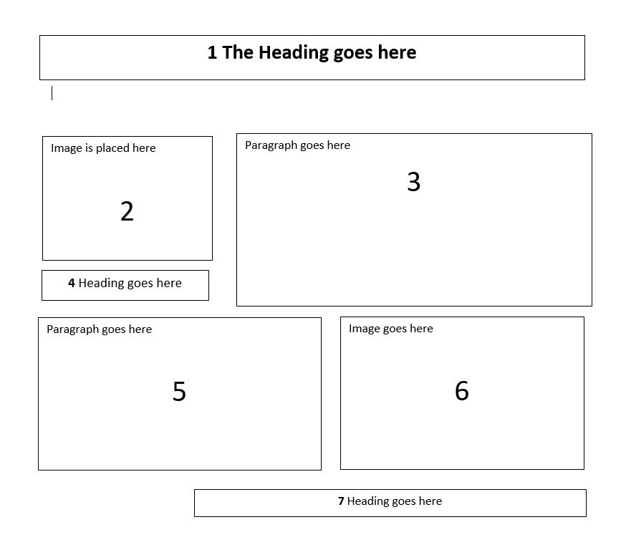

The property bottom is not necessary if you use top, likewise the right property is not necessary if you use left.

