CSCE 102 Lab 12 — Grade Calculator

General information
- Read the entire assignment before you start.
- Always maintain backup copies of your work, and work on the X- drive during lab.
- Never share your password or memory stick with anyone.
- Never email your code to anyone.
- Maintain the standards of academic honesty discussed in lecture and in previous labs. The work you turn in must be your work.

Part I — lab12xx.html – Check your class web page for the deadline.
- Create a table that is structured, with input elements, exactly as shown in Figure below.
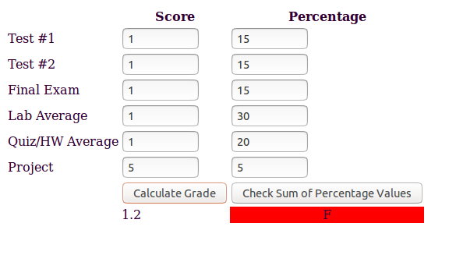

2. When the Check Sum of Percentage Values button is clicked, a JS function needs to be invoked that:
2.1. Calculates the sum of all the values under the heading “Percentage” 2.2. And display appropriate messages within an alert box for each of the following checks :
2.2.a. Each cell must contain a non-zero, positive number.
2.2.b. The sum of all values submitted is a 100.

3. When the Calculate Grade button is clicked call a function that:
- Writes the numeric grade inside the cell located right underneath this button. This is calculated by taking into account the user submitted percentage values for each of the labeled categories.
- And the associated letter grade in the bottom row to the right of the number grade cell within the table. Align these values such that it is displayed in the center of the cell.
- For this problem use:
A 100-90
B+ 89-87
B 86-80
C+ 79-77
C 76-70
D+ 69-67
D 66-60
F < 60
- If the grade is B and above, the background color of the letter grade cell should turn green.
- If the grade is between C+ and D, the background color of the letter grade cell should turn yellow.
- If the grade is F, the background color of the letter grade cell should turn red.
- Use the debugger in Firefox, to find errors in your JavaScript function.
- Open Lab-12 in Mozilla Firefox, press the ALT button on the keyboard. This makes the menu bar visible at the top of the page.
- Click on TOOLS -> WEB DEVELOPER -> DEBUGGER
- You can see the debugger at the bottom of the page, it shows you the errors in the <script> element.
- After debugging your code, make sure you turn off the debugger by accessing TOOLS -> WEB DEVELOPER -> DEBUGGER
- Keyboard Shortcut to turn on/off the debugger: Ctrl+Shift+S

- Save your assignment in your All_102Submissions folder.
Part II — Test case
- Carefully test your code and make sure it is syntactically correct using the HTML and CSS validation tools available online. You are familiar with these as you have used them in previous labs.

Part III — Update All_Index.html
- Include a link to lab12xx.html in the list of links in All_Index.html file
- Ensure that you have a picture of yourself at the top of your All_Index.html

