CSCE 102 Final Project

you will have 3 weeks to work on the project from the day it is assigned.

DO NOT PRINT. turn-in only on the x-drive

read the entire assignment before you start.

All work must be your own.

Create a well-designed, interactive, informative, professional looking website using the following specifications. The layout, content, and navigation needs to be carefully planned after you read the entire assignment before you even start working on it.

General information
- As always, you must write the code for this assignment (with the exception of the one JavaScript that is to be downloaded).
- Don't do the following:
- share your code with other students
- copy from others.
- copy from the web.
- Your code, layout, style and the content of your page will not look like anyone else’s.
- Any cheating will be reported to the Office of Academic Integrity.
- Anyone found guilty of cheating will receive an F in the course.

Task Overview
- Create a folder named Final_Project in your All_102Submissions folder to contain all of your files for the final project.
- You will create exactly 4 web pages for your web site.
- Page 1 - A page about you using the structural/semantic elements, and a slideshow. The slideshow will be taught in class.
- Page 2 – A page about your favorite food that includes image maps.
- Page 3 – A page about your most viewed/liked videos from YouTube and a form used to display the latest user feedback.
- Page 4 – A text based summary of all the neat JS functions you have included within your project. Citations and references pointing to the appropriate web pages within your project or otherwise must be included.
- Each web page must be linked to the others using a translucent menu consisting of the relative hyperlinks. This menu must visually appear as if it were placed over your project webpage. In other words, you must be able to navigate to other pages from every page within your project using the menu displayed as a screen overlay. There is a more detailed description about this later in the document (see Navigation –Screen Overlay.)
Note: You must only have four HTML documents. So plan the layout, style and content carefully. (You must use external CSS and external JavaScript files to interact with the content on your webpages - see Layout and Style Section)

Content and Specifications
Page 1: Topic- About You
- This page must contain the structural/semantic elements using the HTML5 elements; See pages 48 in your Web Design book (by Terry Felke-Morris). Be certain to include a translucent overlay for navigation links to other web pages within your project on this page. This navigation menu should be consistent across all the pages of your project.
- You may want to use different structural/semantic elements for all of your pages and design the menu to appear and behave the same way on every page.
- Display at least 4 thumbnails of your favorite images at the top of this page and a large central image within your page. At the end of this step, you will need to have at least 5 images on your page.
- Incorporate a slide show of these 5 images in the main/central image frame within your page (suggestions for images: They may be related to you/your family/your hometown/your hobbies. Remember, this page is all about you. The images must be clear and not smudged. This means you need to start with a decently large original image file above 800px X 800px.)
- Make the page interesting and ensure the layout looks professional.
____________________________________________________________________
Page 2 – Topic - Your Favorite Food:
- Think for a moment about your favorite foods.
- Choose one that you can write about and find an image online that represents it best. If you have one of your own, you may use it. This is your main image for the page and will be an image map.
- Write at least 2 paragraphs describing the recipe for your favorite food in addition to the following:
- Make sure you include all the ingredients (Hint: lists will come in handy) and the exact details that one must get right to end up with a tasty outcome. (Hint: usage of CSS will help present your content better.)
- Create an image map for your main image. (Don’t resize the image after you identify the co-ordinates for use within your area HTML element.)
- The click-ready hotspots on your image should link to web pages external to your project with more information and should open in a new tab.
- Remember to make the page interesting and the layout look professional.
_____________________________________________________________________

Page 3 – Topic - Create a video library with embedded videos and a feedback form to capture user comments
- Display your favorite videos from YouTube within a table element. Incorporate at least 4 videos for visual content within the second column, one on each row.
- Provide a title/name for each of these videos on the leftmost (i.e., first) column of your table.
- Include a feedback form below the table for the viewers to express their opinion about any one video that they liked the most. As part of the feedback collect the user's intended display name, name/id of the video and their comment.
- Include a button in this form and display all the collected information along with the current date when they click on a Submit button.
- You decide the layout for displaying these comments along with some user information and date on your page. You will need a JS function to do this.
- Note: Do not copy from the web. The text, like the code, must be your own.
- Write a JavaScript function in order to display the latest comment from the user on your web page. (Hint: you will require another HTML element in addition to a form, which acts as a placeholder for the newly added comments. This placeholder could be any h1-h6 or p elements without any content inside.) Display the current date and the user's display name along with the video’s name/id and their comment.
- Refer info from the links: https://www.w3schools.com/jsref/jsref_obj_date.asp ; https://www.w3schools.com/js/js_date_methods.asp )
- Test your JavaScript carefully.
- Include at least one additional JavaScript within this page, which is to be downloaded from the web. You can choose a free JavaScript from the thousands that are available – nothing too tacky.
Note: Do not copy anything from the web. The text, like the code, must be your own with exception of your downloaded JavaScript.
- Again make the page interesting and the layout look professional.
_____________________________________________________________________
Page 4 – Topic - Summary Page
- Create a checklist of all the JavaScript components and features you have implemented on each of the other three web pages discussed in earlier sections.
- Be certain to include information on any interesting/additional JavaScript utilities you may have included within your project.
- Remember to cite your sources if the JavaScript is not your own.
- Specify which of your project pages has the JS statements or functions that you have listed step#2.
- This page is an HTML document and needs to have a navigation menu displayed as a page overlay with links to the other three pages.
_____________________________________________________________________
Layout and Style
- The layout should be more sophisticated than in your other lab assignments. Make it look professional, not flashy or tacky.
- Structure the page with HTML and apply styles to all pages with an external CSS file. (You can also use internal CSS alongside external CSS; but remember it matters whether the link element is above or below the style element.)
- Note that usage of external CSS is mandatory and the internal or inline CSS is optional.
- Be creative and take the extra time to fine tune your page. You will be graded on the usage of appropriate HTML elements for any given task, the page layout, accuracy of your JS code as well as the content, creativity and if all the stated requirements within this document are met.
- Make the pages fit nicely together and look like a website designed to work together; not just random pages. Think about the layout, the style, the navigational flow as well as the content.
- Use some interesting styles in addition to what we have used in class; consider CSS3 box shadow, text shadow, opacity, gradients ,transform or other styles if you have not tried them earlier (some are explained in the HTML5 Web Design textbook by Terry Felke-Morris, you can always refer to W3C).
_____________________________________________________________________
Navigation – Screen Overlay
- The trigger for a navigation menu designed to appear on any page must be placed on the top left corner of every html document within your project.
- This trigger element may be a button/icon/image/text (Hint: pick one or a combination of two or more) according to your preference.
- The navigation should be easy to use and intuitive. This includes the option to view and cancel the menu list according to user's interaction with the webpage.
- You must have a menu with hyperlinks on every page within your project that allows navigation to the other web pages within your project. You must place this menu as a screen overlay over your web pages. This means it must slide out and over your html page that you are on.
- Do not include a link to the current html document, from the document's own menu, i.e, you must not have a link to page1 when you click on the Menu button/icon/image/text (whichever you choose to implement) within page1.
- Include some transitions to make it more interesting and usable for the users navigating your project.
- Test all of your code. Make sure the links and transitions work. When grading your code we will navigate through all of your pages and check every little detail.
- Test your pages in multiple browsers. If you have any specific feature working in some browsers but not in certain other browsers, make sure you document this issue in your Summary page with as much detail as necessary to re-trace and in some cases re-create the said issue.
- All hyperlinks to the web must open in a new tab so that the user will not be redirected away from your project page.
- Make the navigation overlay look professional. Always type your code without copying from the web.
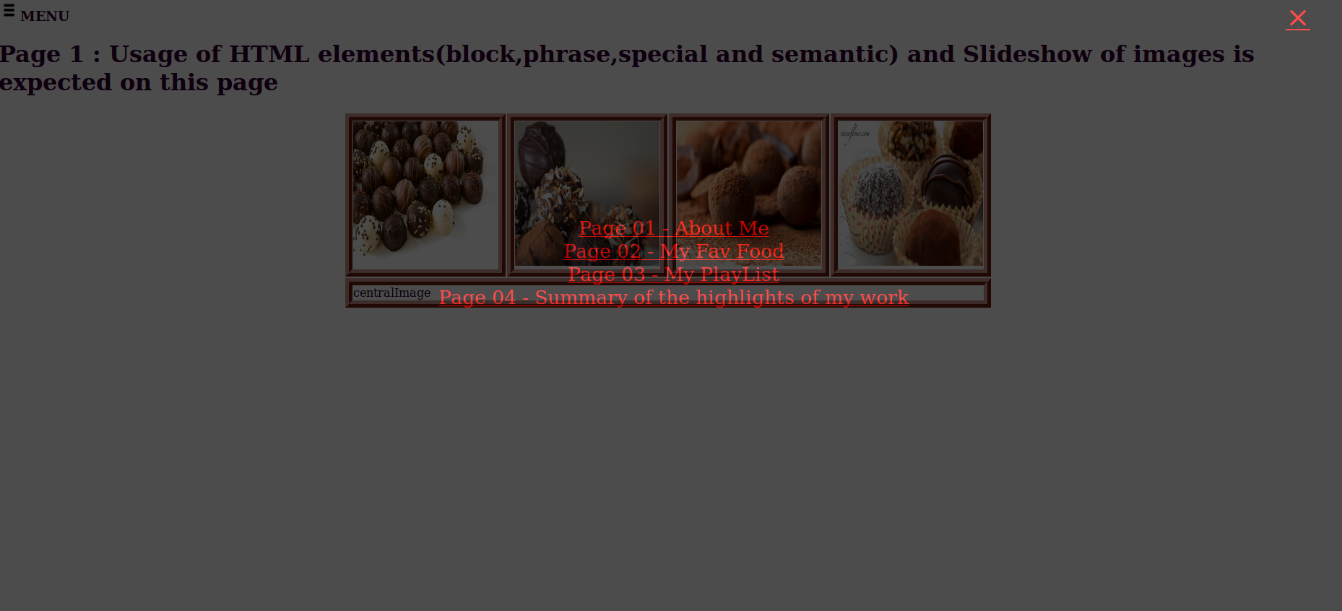
- See a sample screen shot of how the navigation should appear on a page. The descriptions for the items on your navigation menu will be different. Also a link to the current page will be missing from this list as mentioned earlier. Eg: If you click MENU from page1, then that menu list will not include a link to page1 but has links to the other pages within your project. Four hyperlinks are listed on the screenshot below to enable you to comprehend the need to create 4 pages but modify the menu according to the expectations listed earlier in this section.
Hint: Refer to your lab 11-Part A for ideas related to screen overlay. An updated version of the same is available at:Click Here
Remember, your screen overlay needs more structural and styling elements than what is available at the above URL.

Tips and hints
- Prepare a detailed plan for your project before you start writing code. Decide on the content of the page along with the images, links, etc. that will be used.
- Include appropriate comments (implies both style and the level of detail) throughout your code to explain anything unusual or to point out things that were required in the specifications.
- Start early. The project is not something that can be finished on the last day. The labs will fill up during open lab hours since other sections will also be working on their projects.
- All HTML code must be HTML5 compliant.
- Test your page frequently in the browser; it is more difficult to debug after entering a lot of code.
- If you do not know how to do something, refer your notes and text books. If you still need more examples to understand you may search for it online. If you still cannot find the answer, ask.
- Download the images you want to use; do not use the URL's to load images from the internet. All images must be available on your X drive.
- Always save backup copies of your work. Keep more than one copy in more than one place.
- Always work from the X drive when you are in the lab. It is backed up and we can retrieve earlier versions of a file if it becomes corrupted or is accidentally deleted.
- Use the validation tools to check your code before submission at https://validator.w3.org/
- There are lab monitors to help you during open lab hours.
- The project will be graded based on completeness of code and content, accuracy as well as creativity.
- Be creative. You can include sound (this is optional) or additional neat JavaScript functions that you write; include comments that tell what you are doing. You can also look at W3C for other neat JavaScript functions that you can use.
- Your code will not look like anyone else’s. You are to type your own code and content for your project pages. Do not copy text from sources online as you run the risk of introducing encoding related issues without your knowledge and the resulting HTML code will not work as expected.
- Do not copy from the web. That one free JavaScript function must be retyped (not copied from the web) within your external JS file.
- Mention references wherever you think is necessary (video and extra JavaScript that you use from the web) on your Summary Page. Ensure you list all the relevant details that you prefer to highlight to the evaluator of your project, within the Summary page.
- Your final Submission must be placed on your X: drive as per the stated deadline. There is no provision for late submissions. Any submission beyond the deadline is considered as non-submission.

Note:
- Do not submit a print out of the project. Make sure that you submit your project on your X drive by the due date. DO NOT PRINT. ONLY X-drive SUBMISSION IS ACCEPTED.

Embedding a youtube video is as easy as using an image. See https://www.w3schools.com/html/html_youtube.asp

